

**CSE 215L: Programming language II Lab**

**Faculty: Dr. Ziaul Hossain (ZHo)**

**Sec: 06**

**Lab - 04 [Methods], Spring-2021**

**Lab Instructor: Salsavil Kayyum**

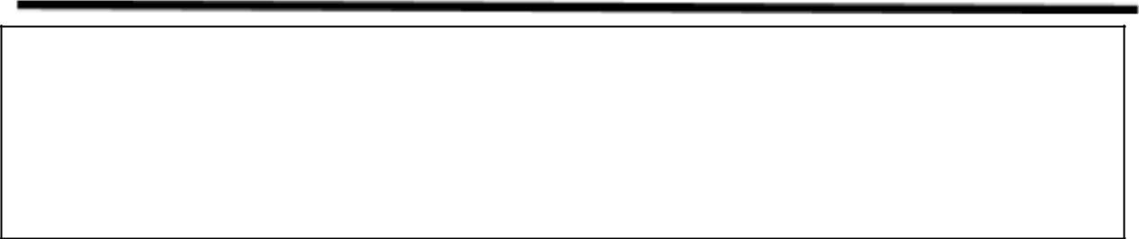

**Objective:**

* Defining a method
* Calling a method
* Passing arguments by values
* Overloading methods

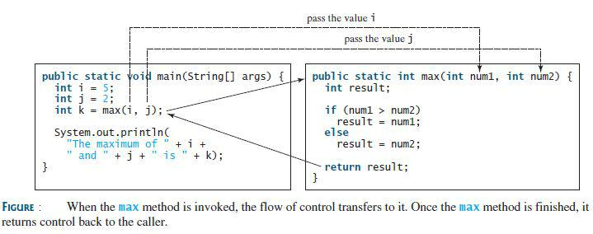

**Tasks:**

1. Write down a method that will take an integer as a parameter and will return 1 if the integer is a perfect number and return 0 otherwise. Using this method, write down a program that will print all perfect numbers between 2 to n where n will be input to your program. Recall that a perfect number is a positive integer that is equal to the sum of its proper positive divisors, that is, the sum of its positive divisors excluding the number itself. For example, 6 is a perfect number because its positive divisors are 1, 2, 3 and the summation of these positive numbers are 1+2+3 = 6, which is the number itself.

|  |  |
| --- | --- |
| **Sample Input** | **Sample Output** |
|  |  |
| Enter n: 500 | 6 28 496 |
|  |  |

1. A 5-digit positive integer is entered through the keyboard, write a method to calculate and return the sum of digits of this 5-digit number passed as a parameter to the method. From the main method, take a 5-digit number as input and use this method to calculate and print the summation of all five digits.

|  |  |
| --- | --- |
| **Sample Input** | **Sample Output** |
|  |  |
| Enter a number: 12345 | Sum: 15 |
|  |  |

1. Write a method ​**isPrime(int N)** that takes an integer and returns true if it’s a prime or false otherwise. Then using ​**isPrime(int N)** method write another method ​**generatePrime(int a, int b)** that takes two integers and prints all the prime numbers in that range.

|  |  |
| --- | --- |
| **Method Call in Main** | **Sample Output** |
| generatePrime(0, 100) | Prime number between 0 to 100  2, 3, 5, 7, 11, 13, 17, 19, 23, 29, 31,  37, 41, 43, 47, 53, 59, 61, 67, 71, 73, 79, 83, 89, 97 |

1. Create a class named ​**MyTriangle** ​that contains the following two methods:

//** Returns true if the sum of any two sides is greater than the third side. *//

public static boolean isValid (double side1, double side2, double side3)

//** Returns the area of the triangle *//

public static double area (double side1, double side2, double side3)

If the sides of the triangle are a, b and c then the formula for computing the area is,Area = $√s\left(s - a\right)\left(s - b\right)\left(s - c\right)$

Where, $s= \frac{a+b+c}{2}$

Write a test program that reads three sides for a triangle and computes the area if the input is valid. Otherwise, it displays that the input is invalid.